First C Program

Before starting the abcd of C language, you need to learn how to write, compile and run the first c program.

To write the first c program, open the C console and write the following code:

1. #include <stdio.h>
2. **int** main(){
3. printf("Hello C Language");
4. **return** 0;
5. }

**#include <stdio.h>** includes the **standard input output** library functions. The printf() function is defined in stdio.h .

**int main()** The **main() function is the entry point of every program** in c language.

**printf()** The printf() function is **used to print data** on the console.

**return 0** The return 0 statement, returns execution status to the OS. The 0 value is used for successful execution and 1 for unsuccessful execution.

How to compile and run the c program

There are 2 ways to compile and run the c program, by menu and by shortcut.

By menu

Now **click on the compile menu then compile sub menu** to compile the c program.

Then **click on the run menu then run sub menu** to run the c program.

By shortcut

**Or, press ctrl+f9** keys compile and run the program directly.

You will see the following output on user screen.

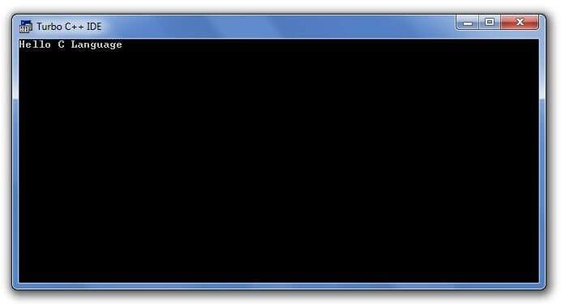

You can view the user screen any time by pressing the **alt+f5** keys.

Now **press Esc** to return to the turbo c++ console.